**FILE PERMISSIONS**

**Linux file permissons**

**Types of permissions**

1. **Basic file/folder permissions**
2. **Special file/folder permissions**
3. **Access control list (ACL)**

**Basic file/folder permissions**

**To check the default permission of a file/folder**

* **# ls -l**
* **# l**

-rw-r--r-- 1 root root 292 Dec 9 12:59 testfile1

drwxr-xr-x 2 root root 54 Dec 8 16:10 secure

* Permissions

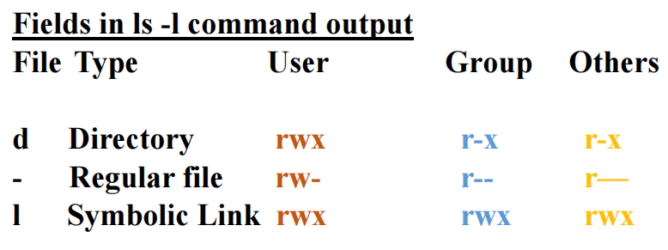

**FILE**

**Read :- Permission to read the file content.**

**Write :- permission to modify the content.**

**Execute :- permission to run the script.**

**Directory/Folder**

**Read :- permission to list the contents (ls).**

**Write :- permission to create or delete file/folder.**

**Execute :- permission to change directory.**

**In Linux, There are three general classes of access**

**(access levels):**

**User (u)**

**The user who owns the file.**

**Group (g)**

**Users belonging to the file's defined ownership**

**group.**

**Others (o)**

**Everyone else.**

**To change the default permission of a file/directory**

**chmod (permission value) <file/directory >**

It was for file defult permission



It was for directory defult permission



**We can use two method to set permissions to**

**files/directories**

1. octal or numeric - 421

2.symbolic - rwx

**values**

read - 4

write - 2

execute - 1

1. **Numaric method**

**chmod 744 <file/directory>**

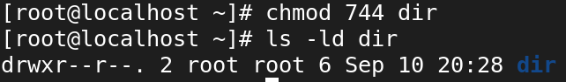

**chmod 440 <file/directory>**

**chmod 244 <file/directory>**

1. **Symbolic method**

**chmod u=rwx,g=rw,o=r <files/directory>**

**chmod u-x,g-rw,o+r <files/directory>**

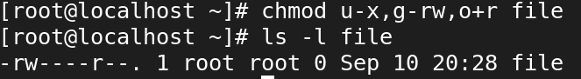

**chmod a=rwx testfile1**

**chmod a-wx testfile1**

**chmod a+wx testfile**

**Who (Letter) Meaning**

**u --> user**

**g --> group**

**o --> others**

**a --> all**

**Default permission for files/Directory**

***root***

**755 - directory**

**644 - file**

**umask**

The user file creation mode mask (umask) is use to determine the file permission for newly created files. It can be used to control the default file permission for new files.

**umask value for root user -022**

**umask value for Normal user -002**

**full permission for file -666**

**full permission for directory -777**

**calculate default permission**

**full permission - umask = default permission**

**root users**

**File**

**666**

**-022**

**-----**

**644**

**Directory**

**777**

**-022**

**------**

**755**

**Reminder**

**chmod 🡺** command to set permission to files/directories

**chown 🡺** command to change owner and group name of files/directories

**chgrp 🡺** command to change group name files/directories